**OUTPUT SCREENSHOTS:**

**Results of running class FlipkartTest:**

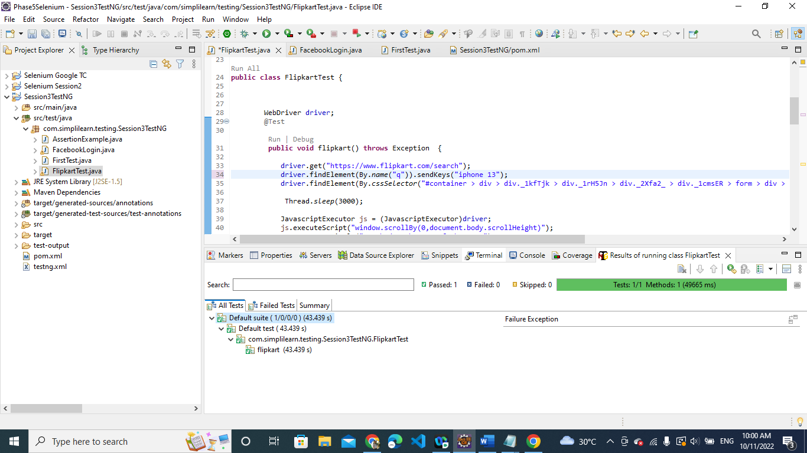

**CONSOLE OUTPUT:**



